13) jump, conditional jump and loop instructions

JMP short [-128;127]

near

far

call: JMP label;

Conditional jumps:

- are of type short;

- if jump>128, replace condition with the negated one and use the JMP statement

- CMP command used for comparing values (for compare & jump)

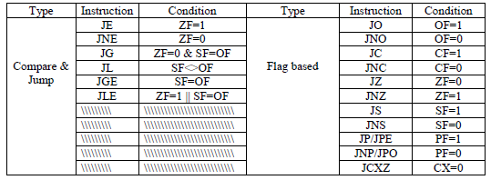

LOOP label (will decrement CX)

LOOPE/LOOPZ label (ZF=1)

LOOPNE/LOOPNZ label (ZF=0)

JA (jump above)

JB(jump below)

JBE  
JAE